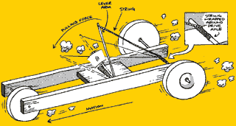
Name: ______________
Class: ______________
Date: ______________
Mousetrap-mobile
http://www.docfizzix.com/mousetrap_car_pictures.htm
http://www.mike.lanham.com/mousetrap/index2.html
http://www.geocities.com/CapeCanaveral/5080/LabReport.html
http://www.flash.net/~funtraps/cars.htm

Specifications:
- Each student must design and build a “Mousetrap-mobile.”
- “Mousetrap-mobile” should be powered by a single, small Victor or d-Con wooden based mousetrap.
- The length and mass of the “Mousetrap-mobile” are the discretion of the student.
- Tests will be performed on the biology lab floor or the gym floor (if more space is needed).

Grading:
The primary focus of this project is the function of the “Mousetrap-mobile.” The grade will be determined on the criteria below, but its fine adjustment will be the discretion of the teacher with respect to design, execution, creativity, and so on.

  - “Mousetrap-mobile” must:
        - be designed and built by student
        - powered only by a single, small, Victor or d-Con mousetrap
        - drive a distance of ≥ 50 cm, under its own power, from a standing start

- In addition to the above, “Mousetrap-mobile” must:
  - Drive ≥ 1 m

- In addition to the above, “Mousetrap-mobile” must:
  - Have wheels made by student
  - Drive ≥ 2 m

- In addition to the above, “Mousetrap-mobile” must:
  - Drive ≥ 3 m

